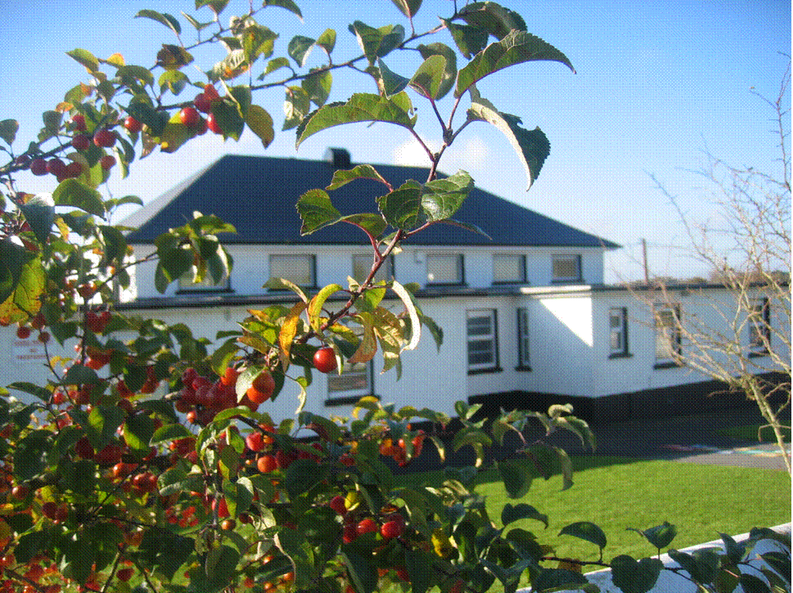 St. Finian’s N.S. Garryhill Co.Carlow
059 9727355 garryhillschool@gmail.com

Code of Positive Behaviour.

The school* recognises the variety of differences that exist between the children and the need to tolerate these differences. It is agreed that a high standard of behaviour requires a strong sense of community within the school and a high level of cooperation between the staff, parents and pupils. The code of positive behaviour will be implemented in a reasonable, fair and consistent manner. (* School = Teachers, pupils, parents and members of BOM)

Aims:

(a) The aim is to provide an orderly environment in which pupils can, through developing self discipline, feel secure and make progress in all aspects of their development.
Teachers will adopt a positive approach to the question of behaviour in the school.

Bullying:

Bullying is always unacceptable. Please refer to the school policy on bullying.

Safety:

For my own safety and the safety of others-
- I should be careful coming to and going home from school
- I should always walk while in the school building
- I should remain seated while in class
- I should show respect for all members of the school community
- I will bring a note to explain my absence from school or to explain why I must leave school early.
- I will never leave the school grounds without the principal’s permission.
- I will not bring a mobile phone or any electronic device which can connect to the internet to school
- I will adhere to the school’s acceptable usage policy of the internet
- If I wear earrings to school I will make sure that they are stud earrings.

Caring for myself;

- I will respect myself and my property, always keeping my school bag, books and copies in good order.
- I will be punctual.
- I will show respect for my school and I will be proud to wear the school uniform.
- I will be aware of my personal cleanliness.
- I will bring a healthy lunch to school.
- I will always do my best in school by listening carefully, working hard and by doing my schoolwork and my homework.

Caring for others:

- I will be respectful to my teachers and other pupils
- I won’t become involved in bullying behaviour.
- I will be honest at all times
- I will respect the property of the school and the property of others.

Timetable:

- School begins at 9.20am.
- Scholl closes at 2pm for infants and at 3pm for all other pupils.

Homework:

It is the policy of the school to assign homework on a regular basis.
Parents are advised to monitor their child’s homework. Parents are asked to sign the homework journal at least once a week. Homework should not be a stressful experience for your child. Your child should not spend more than 1 hour doing homework. Please report any difficulties to the class teacher.

Strategies:
Teachers will encourage and reward positive behaviour
Praise may be given by means of the following-

- A quiet word or gesture from the teacher to show approval
- A comment in the child’s copy or homework journal.
- A visit to another teacher for commendation.
- A word of praise in front of other pupils.
- Pupils work will be displayed prominently.
- A merit mark in the pupil’s copy or homework journal.
- Delegating some special responsibility or privilege.
- Written or verbal communication to parent.

Teachers will challenge every instance of aggressive behaviour.
Disapproval will be shown by means of the following-

- Reasoning with the pupil.
- Reprimand including advice on how to improve.
- The child may be expected to write an account of his/her offending behaviour to be signed by parents (see Appendix A)
- Communication with parent.
- Temporary separation from peers (e.g. sent to other classroom).
- Loss of privilege.(play time, computer time, extra-curricular activity)
- Referral to principal.
- Referral to BOM.
- Suspension/expulsion in accordance with Rule 130 of the Rules for
National Schools as amended by circular 7/88.

1. Success, Criteria and Review

Ongoing monitoring of behaviour in school. Feedback from pupils (circle time, assembly), teachers (staff meetings) and parents (homework journal, informal meeting, formal meeting)

2. Ratification and Communication

A copy of the school code of positive behaviour will be available on the school website www.garryhillschool.ie A copy will be displayed on the school notice board. A copy in draft form will be distributed to each member of the BOM prior to its meeting in January 2013. A copy will be included in the enrolment pack for new entrants.

This policy forms part of the overall school plan for St. Finian’s N.S. Garryhill.

It was ratified by the BOM at its meeting on 23rd January 2013

Signed ________________________________________(chairperson)

