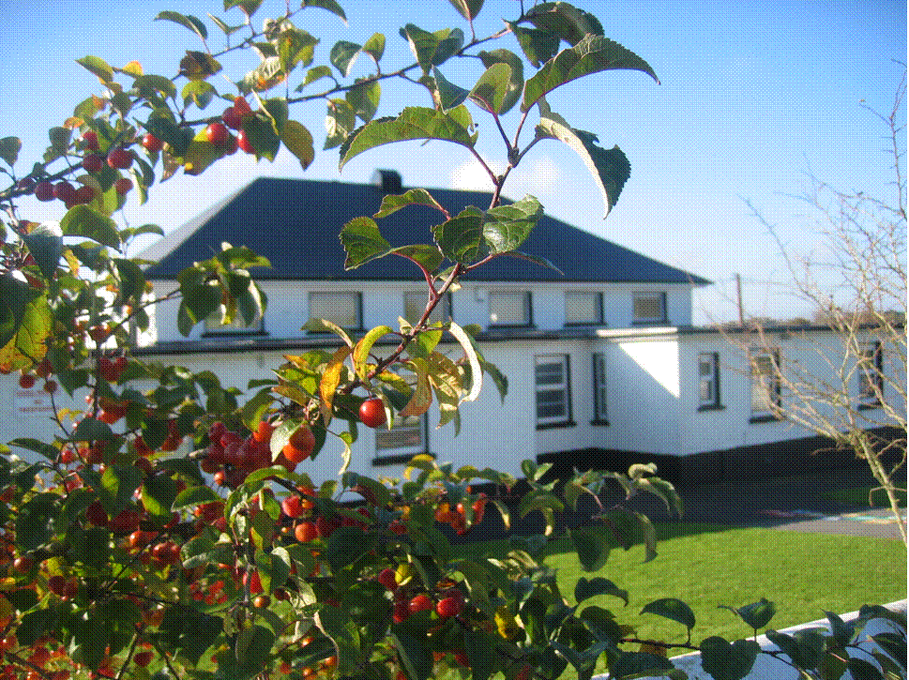 St. Finian’s N.S. Garryhill Co.Carlow
059 9727355 garryhillschool@gmail.com

Anti-bullying policy

- In accordance with the requirements of the Education (Welfare) Act 2000 and the code of behaviour guidelines issued by the NEWB, the Board of Management of Garryhill School has adopted the following anti-bullying policy within the framework of the school’s overall code of positive behaviour. This policy fully complies with the requirements of the Anti-Bullying Procedures for Primary and Post-Primary Schools which were published in September 2013.

- The Board of Management of Garryhill School recognises the very serious nature of bullying and the negative impact that it can have on the lives of pupils and is therefore fully committed to the following key principles of best practice in preventing and tackling bullying behaviour:
- A positive school culture and climate which-
  - is welcoming of difference and diversity and is based on inclusivity;
  - encourages pupils to disclose and discuss incidents of bullying behaviour in a non-threatening environment; and
  - promotes respectful relationships across the school community;
- Effective leadership;
- A school-wide approach;
- A shared understanding of what bullying is and its impact;
- Implementation of education and prevention strategies (including awareness raising measures) that-
  - build empathy, respect and resilience in pupils; and
  - explicitly address the issues of cyber-bullying and identity-based bullying including in particular, homophobic and transphobic bullying.
- Effective supervision and monitoring of pupils;
- Supports for staff;
- Consistent recording, investigation and follow up of bullying behaviour (including use of established intervention strategies); and
- On-going evaluation of the effectiveness of the anti-bullying policy.
- In accordance with the Anti-Bullying Procedures for Primary and Post-Primary Schools bullying is defined as follows:
Bullying is unwanted negative behaviour, verbal, psychological or physical conducted, by an individual or group against another person (or persons) and which is repeated over time.
The following types of bullying behaviour are included in the definition of bullying:
- deliberate exclusion, malicious gossip and other forms of relational bullying,
- cyber-bullying and
- identity-based bullying such as homophobic bullying, racist bullying, bullying based on a person’s membership of the Traveller community and bullying of those with disabilities or special educational needs.
Isolated or once-off incidents of intentional negative behaviour, including a once-off offensive or hurtful text message or other private messaging, do not fall within the definition of bullying and should be dealt with, as appropriate, in accordance with the school’s code of positive behaviour.
However, in the context of this policy, placing a once-off offensive or hurtful public message, image or statement on a social network site or other public forum where that message, image or statement can be viewed and/or repeated by other people will be regarded as bullying behaviour.
Negative behaviour that does not meet this definition of bullying will be dealt with in accordance with the school’s code of positive behaviour.
Additional information on different types of bullying is set out in Section 2 of the Anti-Bullying Procedures for Primary and Post-Primary Schools.

- The relevant teachers for investigating and dealing with bullying are as follows:

class teacher and principal

- The education and prevention strategies (including strategies specifically aimed at cyber- bullying and identity-based bullying including in particular, homophobic and transphobic bullying) that will be used by the school are as follows:

- Enhancing self-esteem: teachers will take every opportunity to praise pupils to reward positive behaviour, to celebrate success, to encourage participation and to display work samples.
- Teachers will challenge all incidents of aggressive behaviour.
- Teachers will foster an ethos of telling and listening and ensure tolerance and respect for telling.
- Teachers will be vigilant in their teaching and supervision of pupils.
- Teachers will emphasise that bullying behaviour is unacceptable in the school
- Anti-bullying will be promoted through SPHE lessons, circle time, Stay Safe Programme, Walk Tall programme, displays and assemblies.

- Model respectful behaviour to all members of the school community at all times.
- Explicitly teach pupils what respectful language and respectful behaviour looks like, acts like, sounds like and feels like in class and around the school.
- Display key respect messages in classrooms, in assembly areas and around the school. Involve pupils in the development of these messages.
- Catch them being good - notice and acknowledge desired respectful behaviour by providing positive attention.
- Consistently tackle the use of discriminatory and derogatory language in the school – this includes homophobic and racist language and language that is belittling of pupils with a disability or SEN.
- Give constructive feedback to pupils when respectful behaviour and respectful language are absent.
- Have a system of encouragement and rewards to promote desired behaviour and compliance with the school code of positive behaviour and routines.
- Explicitly teach pupils about the appropriate use of social media.
- Positively encourage pupils to comply with the school rules on mobile phone and internet use.
- Follow up and follow through with pupils who ignore the rules.
- Actively involve parents in awareness raising campaigns around social media.
- Actively promote the right of every member of the school community to be safe and secure in school.
- Highlight and explicitly teach school rules in pupil friendly language in the classroom and in common areas.
- All staff can actively watch out for signs of bullying behaviour.
- Ensure there is adequate playground/school yard/outdoor supervision.
- School staff can get pupils to help them to identify bullying “hot spots” and “hot times” for bullying in the school. Hot spots tend to be in the playground/school yard/outdoor areas, changing rooms, corridors and other areas of unstructured supervision. Hot times again tend to be times where there is less structured supervision such as when pupils are in the playground/school yard or moving classrooms.

- The school’s procedures for investigation, follow-up and recording of bullying behaviour and the established intervention strategies used by the school for dealing with cases of bullying behaviour are as follows

- Teachers will investigate all reports of bullying behaviour in a calm, unemotional way.
- Instances of bullying will be recorded and reported to the principal.
- Teachers will communicate concerns to parents.
- After any report of alleged bullying behaviour the teacher/principal will speak separately to all children involved and listen to all sides of the story. If the principal/teacher concludes that a child has engaged in bullying behaviour it will be made clear to him/her that he/she is in breach of the school’s Code of Positive Behaviour. The parents of all children involved will be informed of the incident as soon as is practicable by the principal.
- When challenging a bully, the behaviour will be condemned not the child.
- When deemed appropriate, advice will be sought from outside agencies and professionals.
In addition to the above procedures for investigation, follow-up and recording of bullying behaviour teachers will be mindful of the following procedures outlined in section 6.8.9 of Anti-Bullying Procedures For primary and Post-Primary Schools

(i) The primary aim for the relevant teacher in investigating and dealing with
bullying is to resolve any issues and to restore, as far as is practicable, the
relationships of the parties involved (rather than to apportion blame);
(ii) In investigating and dealing with bullying, the teacher will exercise his/her
professional judgement to determine whether bullying has occurred and how
best the situation might be resolved;
(iii) All reports, including anonymous reports of bullying must be investigated and
dealt with by the relevant teacher. In that way pupils will gain confidence in
‘telling’. This confidence factor is of vital importance. It should be made clear
to all pupils that when they report incidents of bullying they are not considered
to be telling tales but are behaving responsibly;
(iv) Non-teaching staff such as secretaries, special needs assistants (SNAs), bus
escorts, caretakers, cleaners must be encouraged to report any incidents of
bullying behaviour witnessed by them, or mentioned to them, to the relevant
teacher;
(v) Parents and pupils are required to co-operate with any investigation and assist
the school in resolving any issues and restoring, as far as is practicable, the
relationships of the parties involved as quickly as possible;
(vi) It is very important that all involved (including each set of pupils and parents)
understand the above approach from the outset;
(vii) Teachers should take a calm, unemotional problem-solving approach when
dealing with incidents of alleged bullying behaviour reported by pupils, staff
or parents;
(viii) Incidents are generally best investigated outside the classroom situation to
ensure the privacy of all involved;
(ix) All interviews should be conducted with sensitivity and with due regard to the
rights of all pupils concerned. Pupils who are not directly involved can also
provide very useful information in this way;
(x) When analysing incidents of bullying behaviour, the relevant teacher should
seek answers to questions of what, where, when, who and why. This should be
done in a calm manner, setting an example in dealing effectively with a conflict
in a non-aggressive manner;
(xi) If a group is involved, each member should be interviewed individually at first.
Thereafter, all those involved should be met as a group. At the group meeting,
each member should be asked for his/her account of what happened to ensure
that everyone in the group is clear about each other’s statements;
(xii) Each member of a group should be supported through the possible pressures
that may face them from the other members of the group after interview
by the teacher;
(xiii) It may also be appropriate or helpful to ask those involved to write down their
account of the incident(s);
(xiv) In cases where it has been determined by the relevant teacher that bullying
behaviour has occurred, the parents of the parties involved should be contacted
at an early stage to inform them of the matter and explain the actions being
taken (by reference to the school policy). The school should give parents an
opportunity of discussing ways in which they can reinforce or support the
actions being taken by the school and the supports for their pupils;
(xv) Where the relevant teacher has determined that a pupil has been engaged in
bullying behaviour, it should be made clear to him/her how he/she is in breach
of the school’s anti-bullying policy and efforts should be made to try to get
him/her to see the situation from the perspective of the pupil being bullied;
(xvi) It must also be made clear to all involved (each set of pupils and parents) that
in any situation where disciplinary sanctions are required, this is a private
matter between the pupil being disciplined, his or her parents and the school;
(xvii) Follow-up meetings with the relevant parties involved should be arranged
separately with a view to possibly bringing them together at a later date if the
pupil who has been bullied is ready and agreeable. This can have a therapeutic
effect;
(xviii) In cases where the relevant teacher considers that the bullying behaviour has
not been adequately and appropriately addressed within 20 school days after
he/she has determined that bullying behaviour has occurred, it must be recorded by the relevant teacher in the recording template.
(xix) In determining whether a bullying case has been adequately and appropriately
addressed the relevant teacher must, as part of his/her professional judgement,
take the following factors into account:
- Whether the bullying behaviour has ceased;
- Whether any issues between the parties have been resolved as far as
is practicable;
- Whether the relationships between the parties have been restored as
far as is practicable; and
- Any feedback received from the parties involved, their parents or the
school principal.
(xx) Where a parent is not satisfied that the school has dealt with a bullying case in
accordance with these procedures, the parents must be referred, as appropriate,
to the school’s complaints procedures;
(xxi) In the event that a parent has exhausted the school's complaints procedures and
is still not satisfied, the school must advise the parents of their right to make a
complaint to the Ombudsman for Children.

- Support:
The school will provide ongoing support for victims of bullying behaviour through vigilant supervision, monitoring and further intervention.
8.Supervision and Monitoring of Pupils

The Board of Management confirms that appropriate supervision and monitoring policies and practices are in place to both prevent and deal with bullying behaviour and to facilitate early intervention where possible.

9. Prevention of Harassment

The Board of Management confirms that the school will, in accordance with its obligations under equality legislation, take all such steps that are reasonably practicable to prevent the sexual harassment of pupils or staff or the harassment of pupils or staff on any of the nine grounds specified i.e. gender including transgender, civil status, family status, sexual orientation, religion, age, disability, race and membership of the Traveller community.

10. This policy was adopted by the Board of Management on 26th November 2013

11. This policy has been made available to school personnel and a copy has been published on the school website. A copy of this policy will be made available to the Department and the patron if requested.

- This policy and its implementation will be reviewed by the Board of Management once in every school year. Written notification that the review has been completed will be made available to school personnel and will be published on the school website. A record of the review and its outcome will be made available, if requested, to the patron and the Department.

Signed: _______________________________ Signed: ___________________________
(Chairperson of Board of Management) (Principal)

Date: ______________ Date: _______________

Reviewed on 26-05-16

Checklist for annual review of the anti-bullying policy and its implementation
The Board of Management (the Board) must undertake an annual review of the school’s anti-bullying policy and its implementation. The following checklist must be used for this purpose. The checklist is an aid to conducting this review and is not intended as an exhaustive list. In order to complete the checklist, an examination and review involving both quantitative and qualitative analysis, as appropriate across the various elements of the implementation of the school’s anti-bullying policy will be required.
Yes /No
Has the Board formally adopted an anti-bullying policy that fully complies with the requirements of the Anti-Bullying Procedures for Primary and Post-Primary Schools?
Has the Board published the policy on the school website and provided a copy to the parents’ association?
Has the Board ensured that the policy has been made available to school staff (including new staff)?
Is the Board satisfied that school staff are sufficiently familiar with the policy and procedures to enable them to effectively and consistently apply the policy and procedures in their day to day work?
Has the Board ensured that the policy has been adequately communicated to all pupils?

Has the policy documented the prevention and education strategies that the school applies?

Have all of the prevention and education strategies been implemented?

Has the effectiveness of the prevention and education strategies that have been implemented been examined?
Is the Board satisfied that all teachers are recording and dealing with incidents in accordance with the policy?
Has the Board received and minuted the periodic summary reports of the Principal?

Has the Board discussed how well the school is handling all reports of bullying including those addressed at an early stage and not therefore included in the Principal’s periodic report to the Board?
Has the Board received any complaints from parents regarding the school’s handling of bullying incidents?
Have any parents withdrawn their child from the school citing dissatisfaction with the school’s handling of a bullying situation?
Have any Ombudsman for Children investigations into the school’s handling of a bullying case been initiated or completed?
Has the data available from cases reported to the Principal (by the bullying recording template) been analysed to identify any issues, trends or patterns in bullying behaviour?
Has the Board identified any aspects of the school’s policy and/or its implementation that require further improvement?
Has the Board put in place an action plan to address any areas for improvement?

Signed _____________________________________ Date ________________
Chairperson, Board of Management

Signed _____________________________________ Date ________________
Principal

Notification regarding the Board of Management’s annual review of the anti-bullying policy

To: _____________________________________

The Board of Management of ____________________ wishes to inform you that:

  - The Board of Management’s annual review of the school’s anti-bullying policy and its implementation was completed at the Board meeting of _______________ [date].

  - This review was conducted in accordance with the checklist set out in Appendix 4 of the Department’s Anti-Bullying Procedures for Primary and Post-Primary Schools.

Signed _____________________________________ Date ________________
Chairperson, Board of Management

Signed _____________________________________ Date ________________
Principal

Recording allegations of bullying behaviour
1. Name of pupil alleged to have been bullied and class group

Name _________________________________________Class__________________

2. Name(s) and class(es) of pupil(s) engaged in bullying behaviour
_________________________________________________________________________________
_________________________________________________________________________________
_________________________________________________________________________________

3. Source of allegation ofbullying concern/report (tick relevant box(es))* |  |  | 4. Location of alleged incidents (tick relevant box(es))*
Pupil concerned |  |  | Playground
Other Pupil |  |  | Classroom
Parent |  |  | Corridor
Teacher |  |  | Toilets
Other |  |  | School Bus
 |  |  | Other
5. Name of person(s) who reported the alleged bullying concern

6. Type of Alleged Bullying Behaviour (tick relevant box(es)) *
Physical Aggression |  | Cyber-bullying
Damage to Property |  | Intimidation
Isolation/Exclusion |  | Malicious Gossip
Name Calling |  | Other (specify)

7. Where alleged behaviour is regarded as identity-based bullying, indicate the relevant category:

Homophobic | Disability/SEN related | Racist | Membership of Traveller community | Other (specify)

8. Brief Description of alleged bullying behaviour and its impact

- Details of actions taken

Signed ______________________________ (Relevant Teacher) Date ___________________________

Date submitted to Principal ___________________

Recording bullying behaviour
This form will be completed once it has been established that bullying occurred.
1. Name of pupil being bullied and class group

Name _________________________________________Class__________________

2. Name(s) and class(es) of pupil(s) engaged in bullying behaviour
_________________________________________________________________________________
_________________________________________________________________________________
_________________________________________________________________________________

3. Source of bullying concern/report (tick relevant box(es))* |  |  | 4. Location of incidents (tick relevant box(es))*
Pupil concerned |  |  | Playground
Other Pupil |  |  | Classroom
Parent |  |  | Corridor
Teacher |  |  | Toilets
Other |  |  | School Bus
 |  |  | Other
5. Name of person(s) who reported the bullying concern

6. Type of Bullying Behaviour (tick relevant box(es)) *
Physical Aggression |  | Cyber-bullying
Damage to Property |  | Intimidation
Isolation/Exclusion |  | Malicious Gossip
Name Calling |  | Other (specify)

7. Where behaviour is regarded as identity-based bullying, indicate the relevant category:

Homophobic | Disability/SEN related | Racist | Membership of Traveller community | Other (specify)

8. Brief Description of bullying behaviour and its impact

- Details of actions taken

Signed ______________________________ (principal) Date ___________________________

