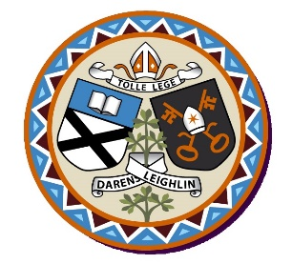
St. Finian’s N.S. Garryhill Co.Carlow 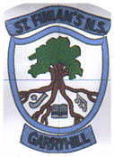

Roll No. 17096k
Annual Admission Notice
in respect of admissions to the 2025-2026 school year

Admission Policy and Application Form
A copy of the school’s Admission Policy and the Application Form for Admission for the 2025-2026 school year is available as follows: –
To download at: www.garryhillschool.ie
On request: By emailing garryhillschool@gmail.com or by request from the school office 059 9727355.

Part 1 - Admissions to the 2025-2026 school year
Application and Decision Dates for admission to 2025-2026 school year
The following are the dates applicable for admission to Junior Infants
The school will commence accepting applications for admission on | 25/10/2024
The school shall cease accepting applications for admission on | 28/02/2025
The date by which applicants will be notified of the decision on their application is | 31/03/2025
The period within which applicants must confirm acceptance of an offer of admission is * | 30/04/2025

Note: The school will consider and issue decisions on late applications in accordance with the school’s Admission Policy.

*Failure to accept an offer within the prescribed period above may result in the offer being withdrawn
Number of Places being made Available in 2025-2026 school year
The number of places being made available in junior infants | 8

Part 2 - Admissions to the 2024-2025 school year.
The school was not oversubscribed in the 2024-2025 school year.

