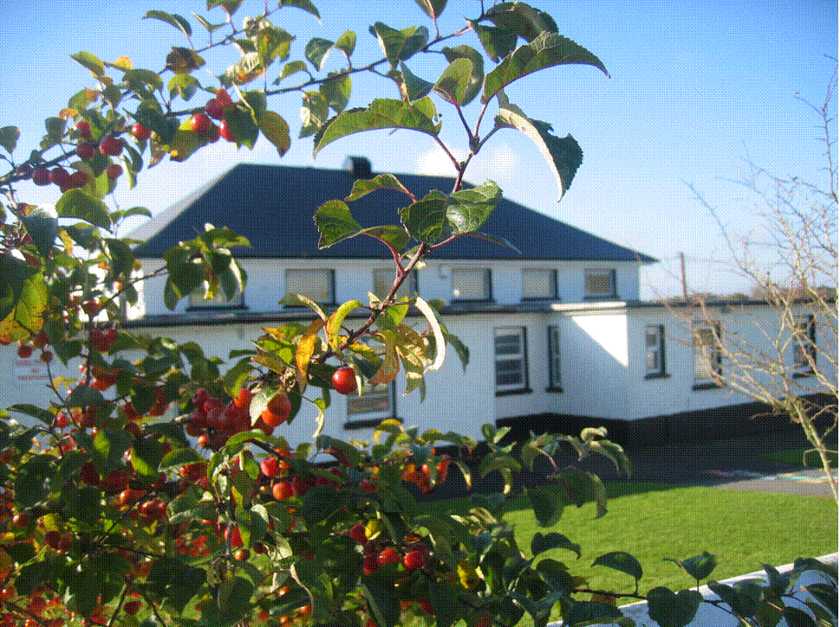**St. Finian’s N.S. Garryhill Co.Carlow **

Office**:** 059 9727355email: [**garryhillschool@gmail.com**](mailto:garryhillschool@gmail.com)

Website: [www.garryhillschool.ie](http://www.garryhillschool.ie)

**School Bí Cineálta Policy to Prevent and Address Bullying Behaviour**

The Board of Management of **St. Finian’s NS Garryhill Co Carlow** has adopted the following policy to prevent and address bullying behaviour.

This policy fully complies with the requirements of *Bí Cineálta: Procedures to Prevent and Address Bullying Behaviour for Primary and Post-Primary Schools* 2024.

The board of management acknowledges that bullying behaviour interferes with the rights of the child as set out in the United Nations Convention on the Rights of the Child. We all, as a school community, have a responsibility to work together to prevent and address bullying behaviour and to deal with the negative impact of bullying behaviour.

We are committed to ensuring that all students who attend our school are kept safe from harm and that the wellbeing of our students is at the forefront of everything that we do. We recognise the negative impact that bullying behaviour can have on the lives of our students and we are fully committed to preventing and addressing bullying behaviour.

We confirm that we will, in accordance with our obligations under equality legislation, take all such steps that are reasonably practicable to prevent the harassment of students or staﬀ on any of the nine grounds specified: gender, civil status, family status, sexual orientation, religion, age, disability, race and membership of the Traveller Community.

# Definition of Bullying

Bullying is defined in *Cineáltas: Action Plan on Bullying* and *Bí Cineálta: Procedures to Prevent and Address Bullying Behaviour for Primary and Post-Primary Schools* as targeted behaviour, online or oﬄine that causes harm. The harm caused can be physical, social and/or emotional in nature. Bullying behaviour is repeated over time and involves an imbalance of power in relationships between two people or groups of people in society. The detailed definition is provided in Chapter 2 of the Bí Cineálta procedures.

Each school is required to develop and implement a Bí Cineálta policy that sets out how the school community prevents and addresses bullying behaviour. Strategies to deal with inappropriate behaviour that is not bullying behaviour are provided for within the school’s Code of Positive Behaviour.

**Behaviour that is not Bullying Behaviour:**

A once-off instance of negative behaviour towards another student is not bullying behavior. However, a single hurtful message posted on social media can be considered bullying behaviour as there is a high likelihood of it being shared multiple times and thus becoming a repeated behaviour.

Disagreements between two pupils, or instances where pupils don’t want to be friends or to remain friends, is not considered bullying unless it involves deliberate and repeated attempts to cause distress, exclusion or create dislike by others by deliberate manipulation of friendship groups.

Some pupils with special needs may have social communication difficulties which may make them communicate their needs through behaviours that can hurt themselves or others. These behaviours, when not deliberate or planned, are not considered bullying behaviour.

# Section A: Development/review of our Bí Cineálta policy to prevent and address bullying behaviour

All members of our school community were provided with the opportunity to input into the development/review of this policy.

|  |  |  |
| --- | --- | --- |
|  | Date consulted | Method of consultation |
| School Staﬀ | 14-01-2025 and ongoing throughout the 24/25 school year. | Croke Park hours, staff meetings, half day closure, Oide seminar |
| Students | Throughout 24/25 school year | Focus group R2 – R5, SPHE lessons all classes, Student Council meetings, creation of a child friendly policy |
| Parents | October 2024  June 2025 | Information leaflets sent to every parent. Written submissions invited from parents  Copy of policy circulated to each family.  Copy on school website. |
| Board of Management | BOM meetings on 24/02/2025 and 12/05/2025 and final meeting of 24/25 school year (June 16th) when policy will be ratified | Item on agenda. Copy of circular with link to Bí Cineálta circulated to each Board member.  Review draft policy leading to consultation and final ratification. |
| Wider school community as appropriate, for example, bus drivers | June 2025 and September 2025  ongoing | Informative discussions between principal, school secretary and school caretaker.  Principal will inform visitors to the school, e.g. sports coaches, of the policy |
| Date policy was approved: 16-06-2025 | | |
| Date policy was last reviewed: 16-06-2025 | | |

# Section B: Preventing Bullying Behaviour

|  |
| --- |
| This section sets out the prevention strategies that will be used by the school. These include strategies specifically aimed at preventing online bullying behaviour, homophobic and transphobic bullying behaviour, racist bullying behaviour, sexist bullying behaviour and sexual harassment as appropriate (see Chapter 5 of the Bí Cineálta procedures): |
| **Culture and Environment:** The Board and staff of **St. Finian’s NS** will strive to:   * Create a school culture where bullying is unacceptable. * Ensure a consistent approach to addressing bullying * Involve parents as active partners in fostering an environment where bullying is not tolerated * Promote the concept of a trusted adult (link to **Stay Safe**) * Create safe spaces in our school buildings and play areas * Ensure adequate supervision of pupils * Create a positive school environment which is welcoming of difference and diversity * Encourage pupils to tell, to disclose and discuss incidents of bullying behaviour in a safe, non-threatening environment. * Promote respectful relationships across the school community.   **These goals will be achieved by:**   * Briefing of staff on a uniform approach to handle reports of bullying. * Anti-Bullying Week. * Child-Friendly Anti-Bullying Policy prominently displayed throughout the school. * Keeping parents informed of anti-bullying procedures. * Completing Stay Safe lessons annually and including positive behaviour lessons in SPHE * Effective supervision and monitoring of pupils. * A No Mobile Phones policy for pupils in St. Finian’s NS   **Curriculum:**   * Completion of Stay Safe programme. * Implementation of the school SPHE curriculum * Model respectful language and respectful behaviour in delivering lessons * Encourage and provide continued professional development for staff * Provide teaching and promote learning which fosters inclusion and respect for diversity * Weave wellbeing throughout lessons. * Use of Webwise resources.   **Policy and Planning:** St. Finian’s NS aims to:   * Develop and implement a Bí Cineálta Policy by the beginning of the 2025/26 school year. * Have a child-friendly Bí Cineálta policy prominently on display throughout the school * Ensure that the school policies on SPHE, Supervision, Code of Positive Behaviour, Child Safeguarding and Acceptable Usage of Internet are reviewed to ensure compatibility with the Bí Cineálta policy. * Ensure effective leadership in the implementation of anti-bullying measures by the principal, DLP and DDLP   **Relationships and Partnerships:**   * Acknowledge and praise respectful behaviour in the classroom and playground. * Give constructive feedback to pupils when respectful behaviour or language is absent. * Support the active participation of pupils in school life through formal and informal structures such as Student Council meetings, assemblies, circle-time activities, reading buddies, wellbeing activities, sports and other activities, focus groups. * Support the active participation of parents in school life by involvement in Parents’ Association, volunteering, fund-raising. * Keep parents informed of school policy. * Board of Management meets at least five times per school year to discuss policy and day to day running of the school. |

|  |
| --- |
| The school has the following supervision and monitoring policies in place to prevent and address bullying behaviour (see Chapter 5 of the Bí Cineálta procedures): |
| * Bí Cineálta Policy * Child- friendly Bí Cineálta Policy * Supervision Policy * Code of Positive Behaviour * SPHE policy which includes Stay Safe |

**Section C: Addressing Bullying Behaviour**

The teacher(s) with responsibility for addressing bullying behaviour is (are) as follows:

Mainstream class teachers and Special Education Teacher

The principal will provide support and become involved where appropriate

When bullying behaviour occurs, the school will:

* ensure that the student experiencing bullying behaviour is heard and reassured
* seek to ensure the privacy of those involved
* conduct all conversations with sensitivity
* consider the age and ability of those involved
* listen to the views of the student who is experiencing the bullying behaviour as to how best to address the situation
* take action in a timely manner
* inform parents of those involved

|  |
| --- |
| The steps that will be taken by the school to determine if bullying behaviour has occurred, the approaches taken to address the bullying behaviour and to review progress are as follows (see Chapter 6 of the Bí Cineálta procedures): |
| Where bullying behaviour is suspected or reported the teacher will consider the following questions:   1. Is the behaviour targeted at a specific pupil or group of pupils? 2. Is the behaviour intended to cause physical, social or emotional harm? 3. Is the behaviour repeated?  * After consideration the teacher will use professional judgement to confirm whether bullying has occurred. * If bullying behaviour has not occurred the teacher will use the strategies in the school Code of Positive Behaviour to deal with the behaviour. * Once bullying has been confirmed the teacher will investigate it and make every effort to resolve the issue and restore as far as is practicable, the relationships between the parties involved. * All reports of bullying will be investigated by the teacher ensuring pupil confidence in telling. * While investigating, the teacher will use professional judgement in relation to actions to be taken, records to be kept and who to involve in discussions. * The teacher will ensure that the pupil experiencing bullying is heard and reassured, the teacher will conduct all conversations with sensitivity considering the age and ability of the pupils involved. * The teacher will allow the pupil who is experiencing the bullying to suggest how best to address the situation. * The teacher will act in a timely manner. * Parents are an integral part of our school community and play an important role in partnership with us in addressing bullying behaviour. Where bullying behaviour has occurred the parents of the pupils involved will be contacted at an early stage by the teacher. * If a group of children is involved the teacher will interview each one individually at first. Thereafter all pupils involved will be met as a group. Each pupil will be supported as appropriate following the group meeting. * Once the teacher has identified a pupil who has engaged in bullying behaviour it will be made clear to the pupil that he/she is in breach of the school’s Bí Cineálta policy and he/she will be encouraged to see the behaviour from the perspective of the pupil at the receiving end of the behaviour. The teacher will explain how hurtful and harmful the behaviour is and elicit a promise from the perpetrator(s) to apologise and stop. * A record of all interactions with pupils will be kept by the teacher. * If the pupil(s) continues to engage in the bullying behaviour the principal will invite the parents for an informal discussion. The principal will give the parents an opportunity of discussing ways in which they can reinforce or support the actions taken by the school. * Repeated incidents of bullying will result in the imposition of sanctions outlined in the school’s Code of Positive Behaviour. * Where a parent is not satisfied that the school has dealt with a bullying case in accordance with these procedures, the parent will be referred to the school’s Complaints procedure. |

|  |
| --- |
| The school will use the following approaches to support those who experience, witness and display bullying behaviour (see Chapter 6 of the Bí Cineálta procedures:  **Supporting the bullied pupils: A whole school approach for supporting pupils will include:**   * Ending the bullying behaviour. * Fostering respect for and greater empathy towards bullied pupils. * Indicating clearly that the bullying and its results are not the fault of the targeted pupil through awareness-raising programmes such as Stay Safe. * Helping targeted pupils to raise their self-esteem by encouraging and facilitating them to become involved in activities that help to develop friendships, social skills and confidence. * By seeking advice and support from NEPS if it’s considered necessary * If the bullying is considered a child protection concern then the advice of TUSLA will be sought * Active and timely engagement and communication with parents * If necessary the child will be offered appropriate counselling   **Supporting the pupil engaged in the bullying:**   * Teachers and parents will focus on, challenge and correct the behaviour while supporting the child. * Helping pupils with low self-esteem to raise their self-esteem by encouraging and facilitating them to become involved in activities that help to develop friendships, social skills and confidence. * A child who engages in anti-social behaviour or who becomes aggressive as a result of engaging in bullying behaviour will be offered appropriate counselling. |
|  |

Procedures to Prevent and Address Bullying Behaviour for Primary and Post­Primary Schools

All bullying behaviour will be recorded. This will include the type of behaviour, where and when it took place, and the date of the engagement with students and parents. The actions and supports agreed to address bullying behaviour will be documented. If the bullying behaviour is a child protection concern the matter will be addressed without delay in accordance with *Child Protection Procedures for Primary and Post-Primary Schools*.

# Section D: Oversight

The principal will present an update on bullying behaviour at each board of management meeting. This update will include the number of incidents of bullying behaviour that have been reported since the last meeting, the number of ongoing incidents and the total number of incidents since the beginning of the school year. Where incidents of bullying behaviour have occurred, the principal will also provide a verbal update which will include where relevant, information relating to trends and patterns identified, strategies used to address the bullying behaviour and any wider strategies to prevent and address bullying behaviour where relevant. This update does not contain personal or identifying information. See Chapter 7 of the Bí Cineálta procedures.

This policy is available to our school community on the school’s website and in hard copy on request. A student friendly version of this policy is displayed in the school and is also available on our website and in hard copy on request.

This policy and its implementation will be reviewed, following input from our school community, each calendar year or as soon as practicable after there has been a material change in any matter to which this policy refers.

Signed: Fr. James Furlong Date: 16th June 2025 (Chairperson of Board of Management)

Signed: Liam Shinnors Date: 16th June 2025 (Principal)