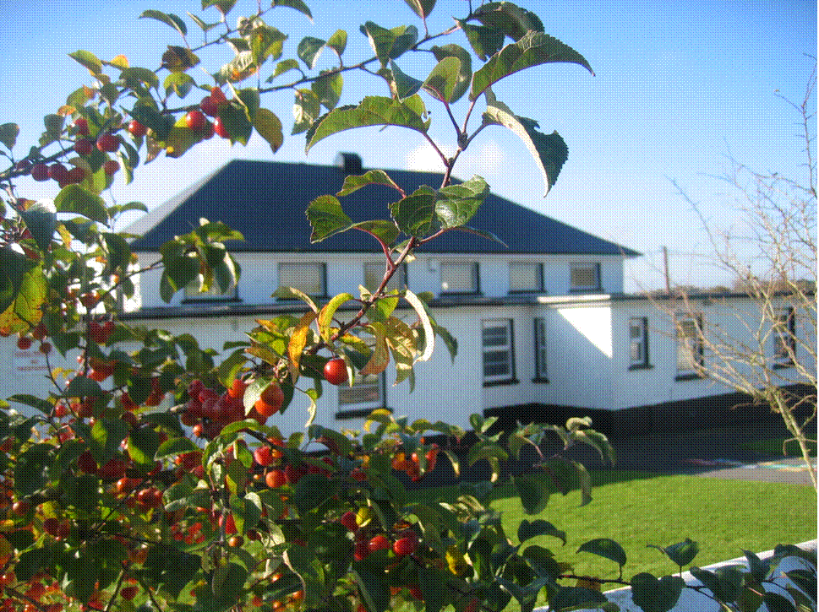 St. Finian’s N.S. Garryhill Co.Carlow 
059 9727355 garryhillschool@gmail.com

Roll No. 17096k

Digital Device and Acceptable Usage of Images Policy

The Board of Management has identified mobile phones, digital devices which can record images or other content and misuse of online platforms and social media as sources of potential harm to pupils. (Child Safeguarding Risk Assessment)
The Board has put this policy in place to address this risk.

Pupils are not allowed to have a mobile phone or any device which can connect to the internet in the school. Pupils who ignore this policy and have such a device in school, will be asked to hand over the device to a member of staff. It will be placed in the school office until a parent comes to collect it. Breaches of this policy will be dealt with under the school’s Code of Positive Behaviour. If it is established that bullying behaviour has occurred, then the behaviour will be dealt with under the school’s Bí Cineálta Policy.

(“A once-off instance of negative behaviour towards another student is not bullying behaviour. However, a single hurtful message posted on social media can be considered bullying behaviour as there is a high likelihood of it being shared multiple times and thus becoming a repeated behaviour”.) School Bí Cineálta Policy June 2025

The Board requests that pupils and parents do not share images on social media.
The Board urges parents to help in this regard.

Staff members use the following guidelines when sharing images:

- Teachers will educate pupils about the risks associated with taking, using, sharing, publication and distribution of images. (Stay Safe, Webwise, SPHE).
- Teachers may take digital/video images to support educational aims.
- Pictures to be published on the school website or elsewhere (e.g. local newspaper) will be selected carefully and will not be published without parental approval.

Mobile Phones

The Board of Management’s policy on mobile phones remains unchanged.
Pupils are not permitted to have mobile phones in school or on school outings.

These policies were reviewed by the Board of Management and they were ratified at its meeting on 16th June 2025

Chairperson: Fr James Furlong 16/06/2025

